Lab 11 task 3: Attach Virtual Machines to the Virtual Machine Port Group
You attach virtual machines to the virtual machine port group so that the virtual machines can communicate with other networked devices.
1. Select VMs and Templates from the Menu drop-down menu.
2. In the navigation pane, expand the Lab VMs folder.
3. Connect the Win10-02 VM to the Production port group.
- In the navigation pane, select the Win10-02 virtual machine.
- Right-click the virtual machine and select Edit Settings.
- In the Edit Settings window, find Network adapter 1.
- Click the downward arrow next to VM Network and click Browse.
- In the Select Network window, select Production and click OK.
- Expand Network adapter 1 and verify that the Connect At Power On check box is selected.
- Click OK to close the Edit Settings window.
4. In the right pane, click the Summary tab.
5. View the VM Hardware pane and verify that the Production port group is listed.
The Production port group has a status of disconnected because the VM is powered off.
6. Power on the Win10-02 VM.
- In the navigation pane, right-click Win10-02 and select Power > Power On.
7. In Win10-02's Summary tab, verify that you are in the classic view of the vSphere Client.
- If you see the CUSTOMIZE VIEW drop-down menu in the Summary tab, then select Switch to classic view from the drop-down menu.
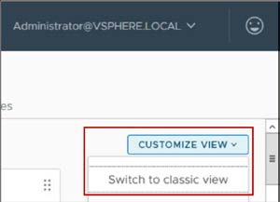
8. In Win10-02's Summary tab, click the Launch Web Console link.
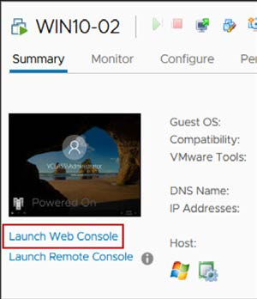
9. Wait for the boot process to complete.
The Win10-02 VM is configured to automatically log you in as vclass\administrator.
10. Renew the virtual machine’s IP address.
- In the VM's console, right-click the Windows Start icon and select Run.
- In the Run dialog box, enter cmd and click OK to open a Command Prompt window.
- At the command prompt, enter ipconfig /release to release the VM's current IP address.
- Enter ipconfig /renew to give the VM a new IP address.
- View the command's output and record the IPv4 address and the default gateway:
- IPv4 address of the virtual machine _ _ _ _ _ _ _ _ _ _
- Default gateway of the virtual machine _ _ _ _ _ _ _ _ _ _
11. At the command prompt, enter ping 172.20.11.10 to verify that the virtual machine is connected to the Production network.
This command pings the Production network's default gateway. Your ping should be successful. If it is not successful, ask your instructor for help.
12. Close the Win10-02 VM's console tab.
13. Repeat steps 3 through 10 on the Win10-04 VM.

